TABLE OF CONTENTS

Acknowledgements 3
INTRODUCTION 5
General Norms of Canon Law 6
Related to Sacramental Records and Recordkeeping 6
Registers in General 7
Ownership and Responsibility 9
Confidentiality 12
Access to Sacramental Records 13
Preservation of Registers 15
Data Entries in Registers 17
General Changes and Additions to Entries 20
Certificates 22
NORMS of CANON LAW 25
Related to Baptismal Records 25
BAPTISMAL REGISTERS 28
Changes and Additions to Baptismal Entries 31
Types of Baptism 34
Adoption and Baptism 40
NORMS of CANON LAW 42
Related to Confirmation Records 42
CONFIRMATION REGISTERS 42
NORMS of CANON LAW 45
Related to Marriage Records 45
MARRIAGE REGISTERS 46
NORMS of CANON LAW 49
Related to Death Records 49
DEATH REGISTERS 49
FIRST COMMUNION REGISTERS 51
(KCSJ Particular Law, per 2018) 51
APPENDIX I 52
SAMPLE ENTRIES 52
APPENDIX II 58
RESOURCES AND WEBSITES 58

Acknowledgements

We are deeply indebted to the generosity and cooperation with the Archdiocese of Atlanta, the Archdiocese of Cincinnati, the Diocese of Charleston (SC), and the Diocese of Dallas for allowing us to use their original handbooks as models for our diocese. I would like to specifically thank Brian Fahey at the Diocese of Charleston; Sarah Patterson at the Archdiocese of Cincinnati; Claire Jenkins at the Archdiocese of Atlanta; and Margaret Gillett at the Diocese of Dallas for their input and continued support throughout this process. Finally, we would like to take the opportunity to express our sincerest thanks to Fr. C. Michael Coleman, JCL; Sr. Rita Killackey, OSB, JCL; and our Vicar General-Chancellor, Fr. Kenneth A. Riley, JCL, for their support and knowledge of Canon Law and its application to the Handbook.

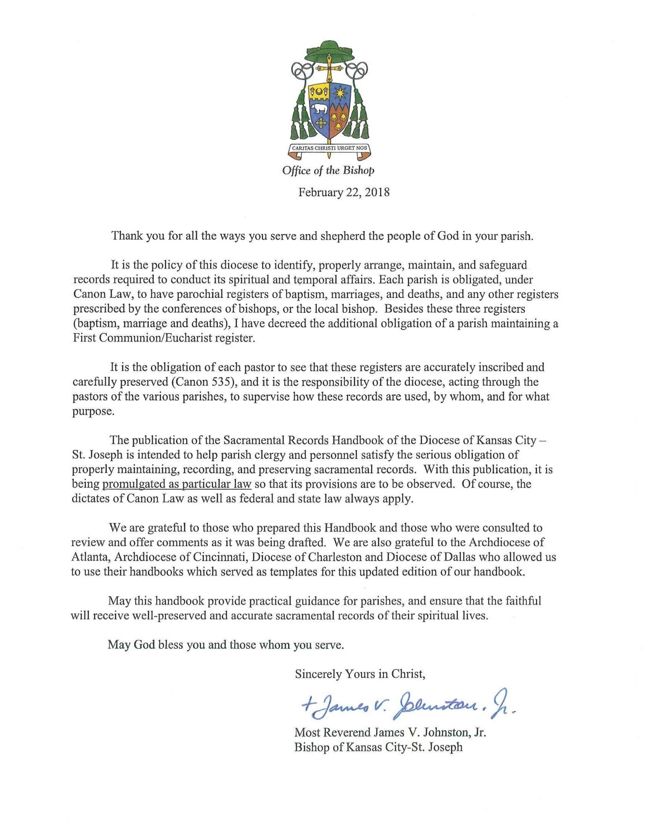

Introduction

The Catholic Diocese of Kansas City-St. Joseph, so as best to continue in service of the Church as well as to protect the spiritual lives of its members, maintains Sacramental Records within the Diocesan Archives. Sacramental records are records created when members of the faithful receive one of the seven sacraments—Baptism, Penance, Eucharist (First Communion), Confirmation, Matrimony, Holy Orders, and the Anointing of the Sick. Records of Baptism, Matrimony, and Death (required by Canon 535) are the most common types of records. Penance records are not made or kept, nor required by canon law to be maintained by Diocesan Archives, and likewise ought not to be kept or maintained by any parish, nor acknowledged through the production of a certificate. Keeping records of Anointing and First Communion is optional. Although not sacramental in nature, Death Registers are nevertheless important to be maintained by parishes that have cemeteries because there may be certain civil laws that apply. The Catholic Cemeteries of Kansas City-St. Joseph, owned and operated by the Diocese of Kansas City-St. Joseph, is available to assist families in prayer and remembrance of the Faithful Departed. [Go to www.cemeterieskcsj.org for more information.]
Sacramental Records are a critical and essential part of the Church, individuals, and communities throughout the Diocese. Since such records are many times the only documents in existence relative to someone’s ancestors, their creation, preservation, and proper use are imperative. The value of sacramental registers is acknowledged not only by Canon law but also civil law as they provide documentation of those who comprise parishes and, collectively, the Diocese. Furthermore, sacramental records document the religious rights of parishioners and record the history of Catholic communities.
Sacramental records are generally made by parish clergy or appointed delegates when the sacrament is performed, and are maintained within individual parishes. Records are to be kept (often by parish secretaries) in special volumes set aside for this purpose and, in turn, are distinct from other parish records. Clergy are required to make and keep the records and since they also have cause to examine earlier records on a regular basis, the records should be carefully prepared and maintained by the parish staff. Records before and including the year 1956 are to be transferred to the Diocesan Archives.
The use and maintenance of sacramental records is governed by Canon Law. The individual rules or canons of Canon Law are often referred to as “norms.” All the canons are compiled in The Code of Canon Law. Each of the sacramental records has associated rules that must be followed by the clergy and parish staff when recording such information. The provisions of Canon Law, as well as Diocesan policies and procedures (particular law for our diocese), have been incorporated and printed within the current Sacramental Records Handbook.
Sacramental records are particularly important to genealogists and the Office of the Vicar General-Chancellor. They are also valuable to ecclesiastic tribunals seeking information for marriage cases and dispensations. Such vital records are comparable to the necessary statistics of births, marriages, and deaths that are maintained by state and federal governments. They are often the only essential records of certain groups of people in existence, especially in periods of history when census taking had not been established.
In 2005, ParishSOFT was instituted in the parishes throughout the Diocese but was discontinued from official use in 2016. However, some parishes and diocesan institutions still utilize ParishSOFT/ConnectNow which is a computer software program that consolidates and manages information, including data that is entered from handwritten sacramental registers. It is a useful tool that collects statistics, keeps accounts of collections and donations, and gathers information on parish families and activities. It can also prepare reports, mailings, and certificates. ParishSOFT procedures may vary from those that are required for paper registers. Some of the more distinct ParishSOFT and ConnectNow procedures will be noted herein. However, for specific details refer to the 2008 ParishSOFT Standard Operating Procedures [See Appendix II: RESOURCES AND WEBSITES].
More than anything else, the Sacramental Records Handbook of the Diocese of Kansas City-St. Joseph is intended to help parish clergy and personnel satisfy the obligation of properly recording, maintaining, and preserving sacramental records. It is also designed to assure consistent recordkeeping in terms of the best practices throughout the Diocese. In being promulgated as law in its usage, the Handbook and its provisions as particular law needs to be observed and serves as a helpful tool to instruct and assist parish clergy and staff in the proper recording of sacramental records. Of course, the dictates of Canon Law, as well as federal and state law, always apply.

General Norms of Canon Law

Related to Sacramental Records and Recordkeeping

CAN. 491 - §1. A diocesan bishop is to take care that the acts and documents of the archives of cathedral, collegiate, parochial, and other churches in his territory are also diligently preserved and that inventories or catalogs are made in duplicate, one of which is to be preserved in the archives of the church and the other in the diocesan archive.
- §2. A diocesan bishop is also to take care that there is an historical archive in the diocese and that documents having historical value are diligently protected and systematically ordered in it.
- §3. In order to inspect or remove the acts and documents mentioned in §§1 and 2, the norms established by the diocesan bishop are to be observed.
Can. 535 - §1. Each parish is to have parochial registers; that is, those of baptism, marriages, deaths, and others as prescribed by the conference of bishops or the diocesan bishop. The pastor is to see to it that these registers are accurately inscribed and carefully preserved.
- §2. In the baptismal register are also to be noted confirmation and those things which pertain to the canonical status of the Christian faithful by reason of marriage, without prejudice to the prescript of CAN. 1133, of adoption, of the reception of sacred orders, of perpetual profession made in a religious institute, and of change of rite. These notations are always to be noted on a baptismal certificate.
- §3. Each parish is to have its own seal. Documents regarding the canonical status of the Christian faithful and all acts which can have juridic importance are to be signed by the pastor or his delegate and sealed with the parochial seal.
- § 4 In each parish there is to be a storage area, or archive, in which the parochial registers are protected along with letters of bishops and other documents which are to be preserved for reason of necessity or advantage. The pastor is to take care that all of these things, which are to be inspected by the diocesan bishop or his delegate at the time of visitation or at some other opportune time, do not come into the hands of outsiders.
- §5. Older parochial registers are to be carefully protected according to the prescripts of particular law.
Can. 876 - To prove the conferral of baptism, if prejudicial to no one, the declaration of one witness beyond all exception is sufficient or the oath of the one baptized if the person received baptism as an adult.
Can. 894 - To prove the conferral of confirmation, the prescripts of Can. 876 are to be observed.
Can. 1573 - The testimony of one witness cannot produce full proof unless it concerns a qualified witness making a deposition concerning matters done ex officio, unless the circumstances of the things and persons suggest otherwise.

Registers in General

Types of Records
Sacramental records are required by Canon Law to be kept according to a formula that varies with each kind of record. Parishes must keep the following sacramental registers: Baptismal, Confirmation, Marriage, and Death (Canons 535-§1, 895, 1121-§1). Listed below is a description of the information contained in the records of the sacraments, as well as in several optional books.

REQUIRED UNIVERSALLY
- Baptisms
Records include the date, the baptismal name of the child at the time of the baptism, the names of the parents [always including the maiden name of the mother], the names of the sponsors [i.e., the godparent(s)], and the printed signature of the officiating priest or deacon. Entries are made in the record books as they occur in time; initial access to these records is therefore by date. Access to names is by the register index.

- Matrimony/Marriages
Records include the date, the names and dates of births of the parties being married, the names of the two official witnesses, and the signature of the officiating priest/deacon. Initial access is also by date and then by the surname of the husband.

- Confirmations
Confirmation is usually administered to youth as part of a group at about the age of fifteen (freshmen and sophomores) and is usually administered by a bishop or his delegate following the various canons in the church and liturgical law. However, confirmation may also be administered to adults enrolled in RCIA (Rite of Christian Initiation of Adults) according to its liturgical book. The records of the sacrament are kept in the parishes. Confirmation records include the date, location, confirming bishop (or delegate), names of those confirmed, and the total number of males and females confirmed.

- Deaths
Records of deaths and burials are kept as part of the parish or mission sacramental records. Burial records more frequently appear as part of cemetery records and are required by Canon Law.

DIOCESE of KANSAS CITY – ST. JOSEPH REQUIRED
- Eucharist (First Communion)
A child usually receives First Communion as part of a class or group about the age of seven. Adults may also receive First Communion as part of a class or group undergoing RCIA (Rite of Christian Initiation of Adults). Individual receipt of First Communion has become increasingly common in recent years.

OPTIONAL REGISTERS
- Anointing of the Sick
Records, when they are kept, include name, and frequently the address and notation of the person’s condition, and may include viaticum notation but without any referencing of confession.

- Ritual Books
A ceremonial book used as part of the Church’s ritual (e.g., Book of the Elect) should be completely distinct from the regular sacramental registers. The data from the ritual register should be transferred to the Baptismal and Confirmation registers as soon as possible after the conferral of sacraments or the reception into Full Communion.

REQUIRED at CHANCERY

- Ordinations
Records of ordinations, received through the reception of the Sacrament of Holy Orders, which are performed by bishops in union with the Holy See, are kept as part of the episcopal register and are not kept at the parish level. Ordination records in the episcopal registers include the date, the name of the person being ordained, the rank to which he is being ordained, and the presiding bishop [See Canon 1053]. The Holy Orders Registers are kept in the “curia of the place of ordination.” Ordinations, however, are noted upon the cleric’s baptismal register entry at his parish of baptism reception into full communion.

Ownership and Responsibility

- Ownership
The ownership of the registers and the ownership of copyrights of all parish sacramental records and those of agencies or institutions within the jurisdiction of the Diocese of Kansas City-St. Joseph reside with the Diocese. Any decisions or issues relating to publishing, microfilming, scanning, replacement, rebinding, repair, or disposal of registers is determined by the Chancellor of the Diocese.

- Required Records
Each parish and mission is required to maintain paper records in bound book format of baptisms, marriages, confirmations, and deaths. Even when a priest serves as pastor of more than one parish, separate registers are to be maintained for each parish. For security and convenience, however, the registers may all be stored at one of the parishes. Maintaining records of First Communions is a requirement of the Diocese of Kansas City-St. Joseph, though they might be noted effectively in the Baptismal Registers. Registers in paper formats are considered the original, essential archival record of sacraments administered in parishes and must be handled, stored, protected, and maintained as such.

- Parishes, Missions, and Other Institutions
Generally, only parishes and missions maintain sacramental records and registers. If a chapel or pastoral center (i.e., school or college campus ministry) operates under the authority of the local pastor, its sacramental records should be kept in the parish registers, rather than separately.

Persons assigned as chaplains or clergy with sacramental responsibility for Catholic or non-Catholic institutions, such as schools, campus ministries, hospitals, etc., that maintain no distinctly Catholic sacramental registers should see to it that the reception of the sacraments of Baptism and Marriage be recorded in the sacramental registers of the territorial parish in which the hospital/institution is located. Such sacraments may not be recorded in the parish where the priest is assigned, if it is not the territorial parish.

If a Catholic institution closes or combines with another institution in a manner that precludes the maintenance of specifically Catholic sacramental records, the registers must be discontinued after three years and transferred to the Diocesan Archives. All future sacraments performed at that location are to be then recorded in the registers of the territorial parish.

- Mission Registers
A pastor or other clergy who oversee a mission church are to maintain for that church a separate set of sacramental registers. As some missions eventually become parishes, the complete record of those particular parishioners can be transferred and then easily located and maintained in one place.

- Responsibility
The creation, preservation, and use of sacramental records are the responsibility of the “person in charge,” whether they be clergy, chaplain, or administrator.

- Delegated Responsibility
The person in charge may choose to delegate the day-to-day administration of sacramental records to a parish secretary or another responsible person. That person should be an employee of the parish or mission, not a volunteer, have knowledge of the parish history and parishioners, and be the same person who enters data in both the paper and digital records to ensure quality control. Persons charged with the task of data entry must go through the screening requirements as determined by the Diocesan Human Resources Office. The screening must be completed for a login to the ParishSOFT system to be established.

- Accuracy of Information
Neither the Archives nor the Diocese guarantees the accuracy of the information recorded in sacramental registers. It is the responsibility of pastors in the parishes to ensure that entries in registers and ParishSOFT and other software are complete and accurate. Quality control initiatives that double-check entries on a regular basis ensures accuracy of recorded data.

- Inspection and Certification of Registers
If the person in charge does not personally make entries in the registers, the records should at least be certified (signed by the pastor or delegated clergy). The Bishop will inspect these registers when visiting the parish.

- Non-Transferable, Non-Loaning
Under no pretext may anyone remove or take any parochial books, including sacramental registers, when leaving the parish or transferring to another assignment. Outside of the legitimate access described in Access to Sacramental Records below, original handwritten sacramental registers or copies of sacramental registers, and the data they contain, whether on paper, microfilm, or digital, can ever be given, loaned, or sold to any person or institution without the written permission of the Diocesan Bishop. Such permission shall specify the conditions for use, duplication, and publication.

- Transfer of Registers to Diocesan Archives
The ordinary repository for sacramental registers is the parish or mission that created them. Since parishes and missions do not have the appropriate archival facilities or the ability to adequately preserve older materials, the Diocesan Archives should be contacted for a potential transfer of registers and related sacramental files to the Archives. Additional volumes that are no longer used or rarely accessed should be sent to the Diocesan Archives. All records dated 1956 or before, are to be transferred to the Diocesan Archives.

- Records of Closed Parishes
If a parish or mission is closed, the registers and all other parochial records shall be surveyed by the Diocesan Archives staff to determine appropriate retention and disposition. Sacramental registers are to be transferred to the Archives after inventory, or to the parish that assumes parochial responsibility for much of the closed parish’s territory. The Bishop designates which parish assume parochial responsibility. The registers may remain in the new parish that assumes parochial responsibility for three years and henceforth are to be sent to the Diocesan Archives, who will assume the responsibility for administering them.

- Inventories of Registers
Canon Law requires that parishes and missions periodically prepare inventories of sacramental registers and send copies of the inventories to the Diocesan Archives.

In the diocese, each July, copies (preferably Excel spreadsheets), of baptism, confirmation, marriage and death registers are to be submitted to the Archives.

Confidentiality

Care must be taken to protect the privacy of people. Although sacramental registers contain information about events often taking place in public and other facts already known to any interested party, they also contain information that is personal and confidential.
- Access to Registers
Sacramental registers after 1956 are maintained in the individual parishes. They are kept for the good of the Christian faithful; however, they are private documents, not public ones. No one other than the pastor or his delegate can claim a right to direct access to registers. [See ACCESS TO SACRAMENTAL RECORDS page 13 below]. Confidentiality of parishioners regarding their information and identity must be protected always.

- Authorized Personnel
The pastor is always and ultimately responsible for the confidentiality of the sacramental registers themselves, as well as any reproductions and entries made in ParishSOFT/ConnectNow (if applicable), or other similar software. He may designate other persons to make entries in the registers, and ParishSOFT/ConnectNow, or other similar software, and to prepare certificates. The designated persons should be employees of the parish, and limited in number as to who has access. The designated persons must be capable of diligent work in not only their recording of parishioner data but also protecting the confidentiality of parishioners.

- Genealogical Research
All current sacramental registers (i.e., those still maintained in the parishes) and ParishSOFT/ConnectNow or other similar software entries should not be made directly available to genealogical researchers to peruse at will. The pastor or other regularly designated personnel may research information as requested on a need to know basis and as work time permits. Any research conducted by parish clergy or staff should be made available on separate paper. Care must be taken not to disclose confidential information. If parish clergy or staff are unsure as to the proper procedure and what constitutes confidential information, they should contact the Diocesan Archives.

The Diocesan Archives is a private facility and is NOT open to those engaged in genealogical studies or family research without approval by the Chancellor or Diocesan Archivist. Requests for general genealogical research may be made to the Archivist and if accepted will be conducted by the Archivist or delegated Archives personnel. Fees are NOT charged to those seeking genealogical information. All requests for individual sacramental records are handled by email, written mail, or telephone according to procedures outlined below. If the church, parish, city, or county where the sacrament took place is not known, it will not be possible to find records of a particular person.

Access to Sacramental Records

- Private and Public
Sacramental records are of a mixed nature—private and public. They are private in that they were created in circumstances presumed to be private and confidential. They are public in that they will stand in civil law as valid and authentic evidence when an appropriate civil record does not exist. However, they are not “public” in the sense that they are open to immediate examination and inspection by anyone who visits the Chancery or Diocesan Archives as those records able to be found in a courthouse or public library.

Sacramental records are not only of value to the persons named in the registers. Approved research—historical, sociological, etc.—can be a valid reason for permitting access to parish records, provided that the following rules of access are utilized to protect the legitimate right of privacy of the persons named in the registers. It is the responsibility of the Diocese, acting in and through the clergy of the various parishes, to supervise how records are used, by whom, and for what purposes. The passage of time has a critical effect on the sensitivity of records. As current events become historical events, the need for withholding them from use is reduced and in some cases, may eventually disappear entirely. As a result, older records may be made more broadly available to researchers, whereas recent records shall be restricted from use. While not strict policy, our practice has been not to allow access for at least twenty-five years. Such access does not imply authority to microfilm, scan, or copy the records. Restrictions, however, do not apply to Death Registers. Below are guidelines governing access to sacramental records, whether they are originals or copies.

- Sacramental Records Up to and Including the Year 1956
All researchers seeking records up to and including the year 1956—the year of the merging of the Diocese of Saint Joseph with the Diocese of Kansas City—are to be referred to the Diocesan Archives (once registers prior to 1956 have been transferred to the Archives from the parishes).

Original registers and microfilm of certain sacramental records and a minimal amount of cemetery records are deposited in the Archives to relieve parish personnel of the responsibility; to preserve the originals from wear and neglect in an appropriate archival environment; to provide physical and intellectual control over the date; and to ensure that researchers receive proper supervision and equal treatment.

Since the safe, secure, convenient, and professional service of the Archives is available, researchers will have no need to use original early registers at the parishes. The rules are designed to protect legal rights and the exercise of responsibilities of all concerned, both civilly and canonically.

- Sacramental Records After the Year 1956
Only authorized and trained personnel can examine sacramental records in the parishes and missions. If a person is seeking their own record or has a legitimate reason to request family records (i.e., a parent of a minor child under 18 years of age or a child seeking records of an infirmed or incapacitated parent with legal proof of guardianship or executor status required), the pastor or appointed parish personnel can examine the registers and issue the required information either directly or by mail. Conversely, if a pastor feels that an exception is justified in a particular case, it is important that he first contact the Chancellor before a decision is made.

If the inquiring person is not known to parish personnel, a signed request with proof of identification (picture ID) is required. If the request is in writing it must be signed and include the name of parents, date of birth, and other pertinent information so that there is no doubt that the person requesting the information is entitled to receive it.

If, because of the age and value of the parish records, the demands of researchers, of if the proper care and preservation of the records becomes burdensome, the pastor should contact the Archives for a possible transfer of registers to the Diocesan Archives where they can be safely preserved and easily administered.

Under no circumstances are sacramental registers to be loaned out to anyone or removed from parish premises or the Diocesan Archives.

- Access Authorization
Requests made by government or corporate agencies (i.e., Social Security Administration, Immigration, insurance companies, etc.) should be accompanied by a signed release by the person whose record is requested (or a legally qualified guardian) authorizing the release of the information. Contact Chancellor’s office.

Subpoenas and other court orders demanding that records be handed over should be accepted, but no records should be handed over to the server of the subpoena. In cases where the pastor or his delegate, has been served a subpoena, before responding, contact the Chancellor immediately.

- Access Fees
Parishes should not charge any fees for providing information from sacramental registers.

Preservation of Registers

- Format
Sacramental information is to be maintained in two different formats: paper and digital. The format of paper has well established archival standards for preservation that differ substantially from those records in digital format. Special register books are available from private vendors and are required by Canon Law. A parish retains separate Baptismal, First Communion, Confirmation, Marriage, and Death Registers. [See Appendix I].

- Acid Free Paper
Since registers are meant for permanent preservation of information, the bindings and paper must be of a quality that is considered permanent and durable. Subsequently, the pages of registers must be made of acid-free paper. The best archival papers are Permalife® and PermaDur®, which are not only acid-free, but alkaline buffered as well. Most of the supply companies in the United States sell registers that are manufactured by the F.J. Remey Co. [See www.fjremey.com]. Registers made by Remey are archival-quality no matter who sells them.

- Ink
Entries should be made in fade-proof, waterproof, acid-free permanent ink. The ink must be black, not blue or any other colors. Felt-tip pens and pencils are not acceptable. Felt-tip pens tend to bleed through paper and pencil fades over time.

The best type of inks are those made for artwork, such as India inks (usually found in cartridges). Avoid fine point pens because often they do not leave a line strong enough to be clearly microfilmed or copied. A medium point on a pen is best. Never use white-out over ink or try to scratch out or erase entries. [See below “General Changes and Additions to Entries”, page 20, for the proper way to make corrections.]

- Repair and Restoration of Registers
As registers become worn, they are to be rebound by a professional binder approved by the Diocesan Archivist. Rebinding that destroys any data or renders any part of the records unusable is unacceptable. Only if a register is beyond repair may the records be transferred to a new register. In such a case, contact the Diocesan Archives where the original register can be safely maintained and preserved after it is copied.

Do not use tape of any kind (even if the brand states that it is “archival”), labels, Post-It® Notes, staples, paper clips, glue, or rubber bands on registers. Since the registers are archival by nature, only a trained conservator or professional bookbinder can be allowed to repair registers. Before beginning any repairs to sacramental books, it is essential that the Diocesan Archivist or staff who are professionally trained in preservation and bookbinding be contacted.
- Safe Storage
The sacramental registers and related sacramental files are to be stored in a locked place, one that is fireproof or fire-resistant, such as a fireproofed file cabinet or safe. They may be removed only by authorized personnel and only for legitimate purposes. The registers may never be taken off the parish premises and away from the secure office site except for microfilming, scanning, and restoration by the Diocesan Archives. Related sacramental files likewise must be preserved. They are never to be glued, stapled, or paper clipped into the actual corresponding register.

Not only must sacramental registers be kept in secure places, but they are also to be stored and handled in an environment that ensures their preservation. Ideally that means a constant cool temperature (70 degrees or colder) with a relative humidity of 40% and no prolonged exposure to sunlight or artificial light.

While most parish offices cannot fulfill such precise requirements, steps can always be taken to avoid high temperatures, dampness, large amounts of exposure to sunlight, and florescent lighting. Never store registers in attics, basements, outside sheds, storage units, or any other structure susceptible to wind or water damage. If a parish does not possess the proper storage environment for sacramental registers, contact the Diocesan Archives.

Typically, the Diocesan Archives uses Gaylord Archival® Blue/Grey Barrier Board Flip-Top Document Cases. Sizes of these boxes varies depending on the size of the documents needing to be stored. These boxes, and all other archival supplies, can be purchased in bulk from Gaylord Archival® at www.gaylord.com.

- Copying Sacramental Registers
Sacramental registers can be protected from loss due to fire, age, or heavy use by making duplicate copies in any one of several ways: transcripts, photocopies, microfilm, or digital scans. However, under no circumstances shall the original registers be discarded. It is required by Canon Law that copies of sacramental records be made for security purposes. The Diocese may undertake a diocesan-wide microfilming or scanning project in the future to duplicate sacramental records. Such a duplication project will be regarded as a means of preservation, not free access or publication. The same restrictions of access apply to copies as to original records.

- Finding Aids to Sacramental Records
Copies of any catalogs, inventories, indexes, or other types of finding aids to sacramental records, either in paper or digital format (not including ParishSOFT/ConnectNow), should be sent to the Diocesan Archives.

- Reporting Loss or Destruction
The loss or destruction of any sacramental register should be reported immediately to the Chancellor.

Data Entries in Registers

On the first page of each register enter the name of the parish, city, date-span (i.e., 2014-2015), the sacrament, and book number if there is one (i.e., Baptism Book 3 or Baptism Book III).

- Types of Data
Only that data required by Canon Law and otherwise necessary for the complete and accurate maintenance of sacramental records is to be entered into the sacramental registers. Parishes and missions are also responsible for maintaining accurate digital data of sacramental records in ParishSOFT/ConnectNow (if applicable), or other similar software.

- Timeliness
Entries should be made as soon as possible after the event to be recorded.

- Chronological Order
Entries should be made in chronological order. If the chronological order cannot be kept in some particular case, a small note should be made in the proper chronological location in the register, cross-referencing the actual entry (e.g., “See COLEMAN, page 31.”) Chronological order does not apply to ParishSOFT/ConnectNow, or other similar software (if applicable).

- Register Columns
Each page of the register has several columns and each column is titled. It is important to enter the data in the proper columns and in the correct fields in ParishSOFT/ConnectNow as well (if applicable). The Sacramental Records Handbook has many references to the Notations column. For the sake of convenience, the column for notations is referred to as the “Notations” column throughout the Handbook. In ParishSOFT/ConnectNow (if applicable), the corresponding sacramental tab is “General Remarks.”

- Index
Every entry is to be listed in the register’s index, according to the person’s last name, (husband’s last name in case of marriage as well as maiden name).

- Style for Names and Dates
In paper registers, use the name as verified on the birth certificate if provided, even if it includes a hyphenated last name. Do not use a hyphenated name that does not appear on the birth certificate. Do not use a Social Security card to authenticate a name. The last name of the entry should be printed in upper case (e.g., “COLEMAN”). In regard to dates, print the name of the month rather than use the month’s number (e.g., “March” instead of “3”) in the paper registers. Use YYYY for the year as in 2018. For digital entries in ParishSOFT/ConnectNow, follow the established naming standards for computer data entries (e.g., “Coleman” should NOT be entered in all capital letters). [See ParishSOFT/ConnectNow Standard Operating Procedures].

- Confidential Data
Data which is confidential and which is not to be included on certificates is to be so marked when entered in the register (e.g., “Confidential—do not include on certificate.”) The provisions of Canon 535-§2 are to be observed. By default, the entries in the General Remarks field in ParishSOFT/ConnectNow are not printed on certificates.

- Entry of Minister’s Name
The actual minister of a sacrament does not need to sign the register if the person making the entry personally witnessed the event or has available a document (e.g., Sacristy Record of Baptism) signed by the minister which certifies the conferral of the sacrament. In these cases, the name of the minister is “printed” in the register. Signed Sacristy Records of Baptism, therefore, become archival in nature and should be saved in a separate file. However, when a pastor delegates the ministration of a sacrament to another cleric (i.e., a deacon or a visiting priest), then that delegation must be noted in the register and signed by the delegate.

- Celebrations Outside a Parish Church Building
When sacraments are administered in places other than a parish church building (i.e., campus chapel, a private home, etc.), in accordance with the Diocesan norms, it is important that the records not be “lost” in an unexpected place and can be retrievable for future reference:

- Baptism. Baptism shall be recorded at the parish whose territory encompasses the location at which the sacrament was celebrated, unless the place of baptism is a Catholic institution which has received permission from the local Ordinary to maintain its own sacramental records.
- Marriage. When the wedding takes place according to canonical form, the sacramental records are entered and kept at the territorial parish within the boundaries of which the wedding was celebrated, unless the place of marriage is a Catholic institution which has received permission from the Chancery to maintain its own sacramental records.
In case of a wedding celebrated with a dispensation from canonical form, the marriage shall be recorded in two places: 1) In the parish of the Catholic party whose clergy prepared the couple for marriage and requested the dispensation (or at least gave permission for another priest to do so); and 2) In the Chancery which granted the dispensation from canonical form. The prenuptial files are to be kept in the first location. The clergy member or the pastor’s delegate who requested the dispensation is responsible for sending the usual notification of marriage to the parish of baptism of the Catholic party or parties. The “pastor” is also responsible for notifying the Chancery that granted the dispensation from canonical form if the marriage was not celebrated.
- Death. If a member of the clergy is called upon to preside at a non-Catholic burial, an entry may be made in the parish’s death register together with a notation concerning the religion of the deceased and the services that were provided. All Catholic funeral liturgies, even if celebrated outside the church building, shall be entered in the parish death records.

General Changes and Additions to Entries

Once entered into a sacramental register, data is considered official and permanent. It may not be modified, except only under special conditions, as detailed below.

- Correct Way to Make Corrections
One of the tests for the validity of a record as legal proof is whether it has been officially kept and whether there have been any alterations. The proper way to correct a factual error (i.e., a name or date) is to add a notation and not to erase or cross out what someone claims is incorrect. The notation must be based on some written proof-of-error (the proof should be identified in the notation).

In case of a technical or incidental error (i.e., spelling, date out-of-sequence, etc.) that is obvious to the “person in charge,” once it is pointed out, a change in the original entry may be made without the need for the notation or proof. Permitted changes include correcting dates, names, spellings, and adoptive parents. In cases of doubt, the Chancellor should be consulted.

Original data should never be scratched out, erased, “whited-out,” covered over, and otherwise destroyed or obliterated. All changes to a record must be visible and dated.

- Style for Minor Changes
Minor changes (e.g., correcting a misspelling) may be made directly to the original entry. Such changes are to be made by drawing a straight, simple line through the word, number, or letter to be changed and printing the change immediately above or below the error. (Example: SULLIVAN)

- Style for Major Changes
Major changes (e.g., to record an adoption after baptism) may require that a new entry be created. In these cases, the original entry is to be preserved without change. A new entry, with all the data from the original entry reproduced (except the relevant change or changes), is to be made in the same register as close to the original entry as possible. Both entries, as well as listings in the index, are to be cross-referenced. “Do Not Issue Certificate from This Record” is to be printed carefully across the face of the original entry.

- Authorization for Insubstantial Changes
An insubstantial error (e.g., misspelling) may be corrected upon request of those persons who have a right to a certificate, as mentioned in the CERTIFICATES section below.

- Authorization for Substantial Changes
More significant errors and other changes require authentic supporting documentation. Such documentation will ordinarily consist of an original, “raised seal” certificate from a civil or ecclesiastical office, court, agency, etc. The issuing agency, date of the certificate, and any protocol number should be printed in the “Notations” column of the register. When an error involves data pertaining directly to the celebration of a sacrament or rite of Christian burial (e.g., date, identity of Godparent) such that no external verifying documentation exists, the written or oral testimony of a reputable witness will suffice. Supporting documents are maintained in the Sacramental Records File.

- Non-Permitted Changes
Some non-permitted changes include:
- New Godparents or Sponsors (The names of Godparents or sponsors are not to be changed because they have died or because parents feel they are no longer suitable. In these situations, parents can ask someone else to serve in the role without making a change in the permanent record or on certificates.)
- Non-adoptive Stepparents
- Customary name or nickname.
- Gender “re-assignment” surgery to a Godparent or Sponsor

Certificates

A certificate is an official document certifying that an individual has received a sacrament. It is an exact duplicate of data already entered in a sacramental register.

- Church Use Only
Certificates of sacraments are intended primarily for internal church use and not for civil or legal purposes. Since certain data is entered in the registers based solely upon the word of someone else (e.g., date of birth of a person being baptized), the certificate is simply repeating that data but is not certifying the given information as true.

- Accuracy Required
As an authenticated (i.e., signed and sealed) transcript of the original record, every certificate must be accurate, legible (preferably typewritten) and complete. It must include all notations except in cases of adoption [See the ADOPTION AND BAPTISM section below].

- Absence of Information
The absence of information to fill an item on a certificate shall be indicated by a line or the words “none” or “not given,” rather than by leaving the space blank. It is also possible to issue a signed and sealed certificate without adding the notations. Certificates of this kind must be clearly marked with the words “FOR NON-SACRAMENTAL PURPOSES” since they are not sufficient to certify the canonical status of an individual.

- Authorized Source of Records
Only the parish or other locations (i.e., Diocesan Archives) holding the original sacramental record may issue a certificate. Only the actual paper register, rather than a microfilm reproduction or a computer record, should be used in verifying information needed in preparing certificates. A computer copy of the record may be used for a certificate if there is assurance that the computer copy corresponds identically to the original paper register. While previous sacramental details should be entered into ParishSOFT/ConnectNow (if applicable) for members preparing to receive another sacrament in a different parish, certificates may only be issued by the parish that confers the actual sacrament or the Diocesan Archives.

- Authorized Requests
Any member of the Christian faithful has a right to obtain a certificate of a sacrament he or she has received and which was recorded in a sacramental register. However, only that person, the parents of a minor, someone with legal guardianship of another, or an ordained pastoral minister at another Catholic parish may have the right to request a sacramental certificate. When the parents of a child are separated or divorced, both parents, regardless of legal custody, are presumed to have a right to a certificate.

- Procedure for Requests
Requests for certificates should be submitted in writing by mail or email, although telephone requests from Catholic parish or agency as well as those authorized to request certificates are acceptable [See AUTHORIZED REQUESTS above]. No information from sacramental registers should be provided by telephone or other electronic means except to another Catholic parish or other Catholic agency. Nevertheless, confidentiality must be maintained at all times to care for the privacy of persons within parish communication.

- Format
Certificates should have an official appearance and should be issued in a consistent format. Parishes may obtain blank certificates from commercial vendors or may have them printed locally. All certificates must bear the name and address of the parish.

- Authentication
Certificates must be typed, printed by computer, or hand-printed in ink. They are to be signed by the pastor or his delegate and impressed with the parish seal. Photocopies and facsimile copies of certificates are not considered authentic documents.

- Required Data
Certificates are to include all data contained in the sacramental register, except that which is marked confidential or extraneous to the person’s canonical status. Data in the “Notations” column are to be included. ParishSOFT/ConnectNow data that is present in the General Remarks field can by typed as needed for printing certificates from a computer (if applicable).

If there is no data in the “Notations” column, the words “No Notations” should be printed on the certificate.

Because a member record may be built with a woman’s married surname in ParishSOFT/ConnectNow, for printing a certificate regarding a “full reception into the Church” that should always reflect a woman’s maiden name, enter the maiden name on the General tab in the Sacramental Details section of ParishSOFT (if applicable).

Certificates issued directly to a parish or other church authority for purposes of a canonical investigation (i.e., pre-marital, Tribunal, etc.) shall be clearly marked “For Canonical Investigation Only,” preferably with a red ink stamp.

- Data on Certificates
Once specific data has been changed in the sacramental register, the original data is not transcribed onto certificates (e.g., the natural parents’ names after adoption).

- Missing Records
Sometimes when a certificate is requested, the record in question cannot be found. If there is any possibility that the sacrament may have been conferred in some other parish, the inquirer should be encouraged to check the sacramental records of that parish or parishes or consult the Archives of the Diocese of Kansas City-St. Joseph. If such a search is unwarranted or fails, Canons 876 and 1573 can be applied.

Only that data which can be vouched for with certainty should be entered in the register, even though doing so may leave an incomplete entry. The name of the witness or witnesses, the date of testimony, and the words “Based on the testimony of ________,” should be printed in the “Notations” column of the register.

Notarized sworn statements of parents, sponsors, and the pastor should be added to the Sacramental Records File and a notation written in the register that the entry is a “recreation of a missing record.” Cross reference to the time when the event should have occurred. In ParishSOFT/ConnectNow, the information should be notated in the General Remarks tab for the corresponding sacrament (if applicable).

Norms of Canon Law

Related to Baptismal Records

CCEO CAN. 296 - §2. In the register of baptisms, a note is to be made of the ascription of the baptized persons to a determined Church sui iuris in accord with the norm of Can. 37, of the administration of chrismation with holy Myron as well as what pertains to the canonical status of the Christian faithful by reason of marriage, with due regard for Can. 840, §3, of adoption, of sacred orders or of perpetual profession in a religious institute. These notations are always to be reported on the baptismal certificate - (Code of Canons of the Eastern Churches). In the register of baptism are also to be noted the enrollment of the baptized into a determined church sui iuris; these notations are always to be noted on the certificate of baptism.

CAN. 535 - §1. Each parish is to have parochial registers; that is, those of Baptisms, Marriages, Deaths, and others as prescribed by the Conference of Bishops or the diocesan bishop. The pastor is to see to it that these registers are accurately inscribed and carefully preserved.
- §2. In the Baptismal Register are also to be noted Confirmation and those things which pertain to the canonical status of the Christian faithful by reason of Marriage, without prejudice to the prescript of Can. 1133, of Adoption, of the reception of Sacred Orders, of perpetual profession made in a religious institute, and of change of rite. These notations are always to be noted on a baptismal certificate.

CAN. 852 - §1. The prescripts of the Canons on adult baptism are to be applied to all those who, no longer infants, have attained the use of reason.

CAN. 869 - §2. Those baptized in a non-Catholic ecclesial community must not be baptized conditionally unless, after an examination of the matter and the form of the words used in the conferral of baptism and a consideration of the intention of the baptized adult and the minister of the baptism, a serious reason exists to doubt the validity of the baptism.

CAN. 870 – An abandoned infant or a foundling is to be baptized unless after diligent investigation the baptism of the infant is established.

CAN. 873 – There is to be only one male sponsor or one female sponsor or one of each.

CAN. 874 - §2. A baptized person who belongs to a non-Catholic ecclesial community is not to participate except together with a Catholic sponsor and then only as a witness of the baptism.

CAN. 876 – To prove the conferral of baptism, if prejudicial to no one, the declaration of one witness beyond all exception is sufficient or the oath of the one baptized if the person received baptism as an adult.

CAN. 877 - §1. The pastor of the place where the baptism is celebrated must carefully and without delay record in the Baptismal Register the names of the baptized, with mention made of the minster, parents, sponsors, witnesses, if any, the place and date of the conferral of the baptism, and the date and place of birth
- §2. If it concerns a child born to an unmarried mother, the name of the mother must be inserted, if her maternity is established publicly or if she seeks it willingly in writing or before two witnesses. Moreover, the name of the father must be inscribed if a public document or his own declaration before the pastor and two witnesses proves his paternity; in other cases, the name of the baptized is inscribed with no mention of the name of the father or the parents.
Regarding CAN. 877 - §3; USCCB General Norms, effective December 1, 2000, Particular Law for the USA:
- For children baptized after their adoption is finalized, the following information shall be entered in the register:
  - the Christian name(s) of the child as designated by the adoptive parent(s);
  - the name(s) of the adoptive parent(s);
  - the date and place of birth;
  - the names of the sponsors selected by the adoptive parent(s);
  - the place and date of the baptism;
  - the name of the minister performing the baptism; and
  - the fact of adoption but not the names of the natural parents.
Baptismal certificates issued by the parish for adopted children will be no different from other baptismal certificates. No mention of the fact of adoption shall be made on the baptismal certificate.
- For children baptized before their adoption is finalized, the following notations shall be added to the baptismal register, but only after the adoption has been finalized and with due regard for the civil law of the jurisdiction:
  - parentheses shall be placed around the names of the natural parents;
  - the name(s) of the adoptive parent(s) shall then be added;
  - the child's former surname shall also be parenthesized and the new surname added; and
  - a notation shall be made that the child was legally adopted.

Baptismal certificates issued by the parish for these individuals shall give only the name(s) of the adoptive parent(s), the child's new legal surname, the date and place of baptism, and the name of the minister who conferred the sacrament. The name(s) of the sponsor(s) shall not be given, and no mention of the fact of adoption shall be made on the baptismal certificate.
For future ease in reference, and to afford what may often be the only possibility of reference after the adoption has been finalized, a baptismal entry for the adopted child can be made in the baptismal register of the adoptive parents' parish, citing the date and location of the original baptismal record, and listing only the name of the adoptive parents, and the date and place of birth.
Parish personnel having access to parish registers have an obligation not to disclose to any person any information which would identify or reveal, directly or indirectly, the fact that a person was adopted.
CAN. 878 – If the baptism was not administered by the pastor or in his presence, the minister of baptism, whoever it is, must inform the pastor of the parish in which it was administered of the conferral of the baptism, so that he records the baptism according to the norm of Can. 877 - §1.
CAN. 1685 – As soon as the sentence is executed, the judicial vicar must notify the local ordinary of the place in which the marriage was celebrated. The local ordinary must take care that the declaration of nullity of the marriage and any possible prohibitions are noted as soon as possible in the marriage and baptismal registers.

Baptismal Registers

Baptismal Entries
The Baptismal Register serves as the “master record” for a person’s membership or one of the Christian faithful in the Church and therefore notations concerning other sacraments received later in life are also recorded within.

- Types of Data
For baptism celebrated under normal circumstances, the following information is to be entered in the Baptismal Register [See sample entry on page 52]:
- The Christian name(s) of the child as designated by the parent(s)/adoptive parent(s) or the legal name of the adult (always use the maiden name of a woman)
- The name of the father (first, middle if any, and surname) and the name of the mother (first, middle if any, and maiden name), or names of adoptive parents.
- The date and place of birth
- The name(s) of the sponsor(s), godparent(s), or witness(es)
- The place and date of the baptism
- The name of the minister performing the baptism.

- Sources of Data
Ordinarily the data used to create a record of baptism originates on a “Sacristy Record of Baptism,” a small form from a preprinted pad, sold by commercial vendors. The Sacristy Record is filled out by someone in the parish office at the time the baptism is scheduled, by a member of the baptism preparation team during the catechetical program, or by the minister of baptism at the time of the actual baptism. Before the data is transferred to the Baptismal Register, a parent, guardian, or adult candidate should verify the data written on the Sacristy Record (usually at the time of baptism), and the minister must sign the Sacristy Record verifying that the sacrament was conferred. There should be a clear procedure in place for assuring that the data is transferred from the Sacristy Record to the Baptismal Register as quickly and as accurately as possible. These sacristy record forms are also to be saved, filed and stored.

- ParishSOFT/ConnectNow Entries (Use where applicable)
When a person or family moves from one parish to a new one after January 1, 2005, their sacramental records are not found in the new parish’s ParishSOFT/ConnectNow records, yet are needed to receive additional sacraments, such as Confirmation or First Communion. Request a copy of the baptismal certificate from the parents or from the old parish. Once the hard copy is received, input the earlier information into ParishSOFT/ConnectNow. When entering the Church of Baptism, search for parish using the Online Catholic Directory. Fill out the entire record in ParishSOFT, including the general information.

- Visiting Clergy or Christian Faithful
When a priest or deacon baptizes in a parish church to which he is not assigned, he is responsible for the filing of the necessary records. The baptism shall be recorded in the parish where the baptism took place. If the family is registered in a parish other than the one in which the baptism took place, the baptism is to be recorded in the parish church where the sacrament was celebrated. In such a case, a notice shall also be sent to the family’s own parish requesting that the name of the person baptized be entered into a baptismal register with an indication of where the actual baptismal record can be found.

- Supporting Documents
Certain notations in the baptismal register are accompanied by legal documents that serve as evidence and should also be preserved. Examples include adoption documents proving paternity, affidavits concerning previously omitted baptisms, and notarized court and governmental documents regarding name and/or date changes. After the appropriate notations are made, the items must be kept permanently in a separate file corresponding to each register and page number. The Sacramental Records File must be referred to in the notation.

- Recipients from More than One Parish
When persons from more than one parish are baptized or received into full communion with the Catholic Church at a single ceremony, the record for all the persons is to be retained at the parish where the rites were celebrated. Notifications to parishes of registration are encouraged.

- Godparents
No more than two names may be entered in the “Godparents” or “Sponsors” column. Canon 873 stipulates one and no more than two sponsors (one male and one female) for baptism. Canon 874 - §2 allows a baptized person, who is not a member of the Catholic Church, to serve as “a Christian witness.” The designation “CW” might be useful for clarity. Church law holds that a baptized Eastern Orthodox is properly a Godparent and not a Christian witness. When a Godparent or sponsor appoints a proxy to participate in the rite of baptism, both names should be entered in the register with “Proxy” written after that person’s name. The names of Godparents or sponsors are not to be changed later in the baptismal register because they have died or because parents feel they are no longer suitable. In these situations, parents can ask someone else to serve in the role without making a change in the permanent historical record or on any certificates issued.

- Unmarried Parents
It is important that the provisions of Canon 877 concerning unmarried parents be followed. It is unjust and canonically wrong to enter unauthorized names of parents in the Baptismal Register.

- “Illegitimacy” Tradition
If a child is born of an unmarried mother, the name of the mother is to be inserted in the baptismal register. Likewise, the name of the father shall be inserted in the register if his paternity has been proved either by some public document or by his own declaration before the pastor and two witnesses. If these conditions are not met, the child is to be recorded as being of “Unknown Mother” or “Unknown Father;” in Latin, mater ignota or pater ignotus. It is not permitted to make an annotation that states “Illegitimate.”

- Baptismal Certificates
The issuance of a baptismal certificate should reflect what is recorded in the Baptismal Register. Its purpose is to prove the fact of baptism and the reception of any subsequent sacrament or church action that affects that person’s status in the Church. Once specific data has been changed in the sacramental register, the original data is not transcribed onto certificates (e.g., the natural parents’ names after adoption). See the REGISTERS IN GENERAL section for more information regarding certificates.

The reason for obtaining a baptismal certificate include:
- The fact of valid baptism and Catholicity will be established.
- Any previous reception of valid confirmation, especially in the case of Catholics who were baptized in Eastern Catholic Churches, will be established.
- Any discrepancies between name and parentage in the Baptismal Register and given at the time of confirmation will be discovered.
- The identity of baptismal Godparent(s) can be ascertained.

Changes and Additions to Baptismal Entries

The baptismal record is the primary sacramental record for Catholics. It serves as an official record log for all the significant, public developments in one’s relationship with the Church. As a result, most changes to entries in the sacramental registers are to be made in the Baptismal Register and then updated in ParishSOFT/ConnectNow (if applicable).

- Changes to Original Data
Some changes are actual modifications of the original data entered for baptism; for example, change of name or change of parent. Baptismal records can be recognized as legal documents so it is not up to pastors or staff to alter them to suit a person’s preference later in life. Directions for making any changes can be found in the REGISTERS IN GENERAL Changes and Additions to Entries – minor or major, section above.

- Additions to “Notations” Column in Baptismal Register
Changes are often additions to the “Notations” column. For example, when a Catholic is confirmed, married, or ordained, the parishes where these sacraments are celebrated notify the church of baptism, so the recaption of these sacraments can be noted in the Baptismal Register [See sample entries on page 52] and entered into ParishSOFT/ConnectNow (if applicable). Also, when a marriage is declared null or when an individual is dismissed from the clerical state, the tribunal will notify the church of baptism, so that a notation can be made in the person’s baptismal record.

Types of notification include confirmation, marriage(s) (including convalidations), reception of Holy Orders, perpetual profession in religious institute, and change of rite. Notations of annulment (and prohibitions on future marriages), dismissals (laicization), and dispensation from vows shall also be entered when requested officially by the appropriate ecclesiastical authorities. Notification documents should include a “turn around” document, (an acknowledgement of notation added to that person’s sacramental record), to verify notations have been recorded. Notations may be entered in the General Remarks field of ParishSOFT (if applicable) under the matrimony tab.

- Defection from Church; “Withdrawal” from Church
A parish occasionally will receive a notification from an individual or a church indicating that the person feels he or she is no longer a Catholic and even asking that his/her name be removed from Catholic church records. While it can be pastorally appropriate to remove the person’s name from the parish membership registration or database, NO changes are to be made to the sacramental records. A formal defection has many elements. For valid determinations, please contact the Vicar General-Chancellor’s office. In the “Notations” column of the Baptismal Register: “Formal defection from Catholic Church, [date].” Such situations may call for a letter to the individual explaining the parish’s actions and inviting the person to return to the Catholic Church at a later date.

For a person to make a formal defection from the Church, the following conditions are necessary:
- The internal decision to leave the Catholic Church
- The realization and external manifestation of that decision
- The reception of that decision by the competent ecclesiastical authority (e.g., Ordinary).
Because of the importance of pastoral understanding of “Defections” and “Withdrawals” from the Catholic Church the Actus Formalis Defectionis ab Ecclesia Catholica (Prot. N. 10279/2006) from the Pontifical Council for Legislative Texts, 13 March 2006 is instructive:
1. For the abandonment of the Catholic Church to be validly configured as a true actus formalis defectionis ab Ecclesia so that the exceptions foreseen in the previously mentioned canons would apply, it is necessary that there concretely be:
a) the internal decision to leave the Catholic Church;
b) the realization and external manifestation of that decision; and
c) the reception of that decision by the competent ecclesiastical authority.
2. The substance of the act of the will must be the rupture of those bonds of communion – faith, sacraments, and pastoral governance – that permit the Faithful to receive the life of grace within the Church. This means that the formal act of defection must have more than a juridical-administrative character (the removal of one’s name from a Church membership registry maintained by the government in order to produce certain civil consequences), but be configured as a true separation from the constitutive elements of the life of the Church: it supposes, therefore, an act of apostasy, heresy or schism.
3. The juridical-administrative act of abandoning the Church does not per se constitute a formal act of defection as understood in the Code, given that there could still be the will to remain in the communion of the faith.
…
5. It is required, moreover, that the act be manifested by the interested party in written form, before the competent authority of the Catholic Church: the Ordinary or proper pastor, who is uniquely qualified to make the judgment concerning the existence or non-existence of the act of the will as described above in n. 2.
Consequently, only the convergence of the two elements – the theological content of the interior act and its manifestation in the manner defined above – constitutes the actus formalis defectionis ab Ecclesia catholica, with the corresponding canonical penalties (cfr. can. 1364, § 1).
6. In such cases, the competent ecclesiastical authority mentioned above is to provide that this act be noted in the baptismal registry (cfr. can. 535, § 2) with explicit mention of the occurrence of a “defectio ab Ecclesia catholica actu formali”.
Reunion with the Church should be noted but only if the parish of baptism is made aware of the reunion. In ParishSOFT (if applicable), change the Member Status to Inactive. If it is a single person household, unregister the Family Record and change the Family Group to Inactive. On the Member Record, under the Sacrament Details for the General tab, make the notation in the General Remarks field.

Types of Baptism

- Emergency Baptism
When a baptism is conferred in an emergency, the supplemental ceremonies may be supplied at a later date. The baptism, if it is a Catholic baptism, is recorded properly in the territorial parish where the emergency occurred; that is, where the hospital or other place is located. If the ceremonies are supplied later [cf. 1973 Rite of Baptism for Children No. 31.3], a notation should be made in the margin indicating the date and place the ceremonies were supplied.

- Conditional Baptism
When the rare event of a conditional baptism is conferred, “Baptized Conditionally” is to be written in the “Notations” column [See sample on page 52]. Otherwise, the entry is the same as for any other baptism. By virtue of Canon 869-§2, baptisms in most other faiths are presumed valid until the contrary is demonstrated. Therefore, only after careful investigation and with a positive doubt remaining as to the fact of a baptism or its valid celebration, a person is conditionally baptized. This conditional baptism is done privately (i.e., unceremoniously and only with essential participants in attendance). There exist many steps, including the Bishop’s (or his delegate) determination of what rites are to be celebrated during the private, conditional baptism. Contact Chancellor Office for more information and direction.

If the original attempt at baptism was celebrated in a Catholic Church, the conditional baptism should be noted in the margin of the entry that recorded the original baptism. If the original attempt was in a non-Catholic community, a new entry should be made in the register of the parish within whose boundaries the conditional baptism was celebrated. In such cases the date and place of baptism should be noted instead of the purported earlier baptism. A note as to its conditional celebration should be included. The entry should also be made in ParishSOFT (if applicable) with the phrase “Baptism Conditional” entered in the General Remarks field.

- Catechumens
The names of catechumens are to be recorded in the parish register of catechumens, after the “Rite of Acceptance into the Order of Catechumens,” along with the names of the sponsors and the minister and the date and place of the celebration. Once the elect receives the Sacrament of Initiation, their names shall be recorded in the Baptismal Register. Notations shall be recorded in the universally required Confirmation Registers, and in the diocesan particular law required Communion Registers as well. Note that since 1983 confirmation is ordinarily administered at the time of the profession of faith so that the proper entry must also be made in the parish confirmation register. The “sponsor” for a person joining the Church typically serves also as the sponsor for confirmation.
Definition of Terms
RCIA. Outside of emergency situations, adults and children over seven years of age are required by Canon Law to participate in a process of formation governed by the “Rite of Christian Initiation of Adults.” RCIA culminates in the celebration of all three sacraments of initiation—baptism, confirmation, and first reception of the Eucharist—the same ceremony. Information concerning those who receive the sacraments of initiation shall be recorded in the Baptismal and Confirmation Registers.
Catechumens. A catechumen is a person who is not yet baptized at all and who has celebrated the “Rite of Acceptance into the Order of Catechumens” as part of RCIA. The name of a catechumen, along with the names of the sponsor, officiating minister, and date and place of the celebration, is entered into a special register of catechumens. Note that already-baptized candidates for full communion and confirmation technically are not catechumens and that these persons’ names are not placed in the catechumenal register.
Elect. An “elect” person is a catechumen who has subsequently celebrated the “Rite of the Election or Enrollment of Names” as part of RCIA, and so has been chosen by the Church to receive the sacraments of initiation. The name of an elect catechumen, along with the name of the sponsor, officiating minister, and date and place of celebration, is entered into a special “Book of the Elect.” Note that already-baptized candidates for full communion and confirmation technically are not catechumens and do not become members of the Elect, and that these persons’ names are not placed in the “Book of the Elect.”

- Reception into Full Communion/Professions of Faith
The names of persons who are baptized Christians and who then enter into Full Communion with the Catholic Church by means of a Profession of Faith shall be recorded in the parish baptismal register under the date of profession, together with the date and place of baptism of the party, and all other information as required, as well as the date, if known, even if only approximate, of the non-Catholic baptism.

When persons are received into Full Communion with the Catholic Church, after having been baptized previously in another Christian church, an entry must be made in the Baptismal Register and in ParishSOFT/ConnectNow (if applicable). The data concerning the Rite of Reception should be entered in the spaces provided for baptism, and the data concerning the original baptism should be entered in the “Notations” column, especially the date and place [See sample entries in Appendix I]. In ParishSOFT, enter the data concerning the Rite of Reception on both the Baptism and RCIA tabs. On the Baptism tab under General Remarks, enter the data concerning the original baptism (if applicable).

Special care must be taken to follow the proper procedure when young children are received into full communion along with their parents. In such cases, it is suggested that the ceremonies be supplied as in an emergency baptism, so there is a formal reception into the Church. [For further details, see Bringing a Baptized Child into the Church].

The date the ceremonies were performed should be noted in the spaces provided for Baptism. The data concerning the original baptism should be entered in the Notations column and in ParishSOFT’s General Remarks field, especially the date and place.

For the “Full Reception into the Church” celebrated for a baptized adult (RCIA), the following information is to be entered in the Baptismal Register and in ParishSOFT (if applicable):
- The given or Christian name(s) of the person (use the maiden name of a woman). Because a member record may be built with a woman’s married surname in ParishSOFT, for certificate printing, manually enter the maiden name once the certificate is generated, if applicable.
- The name of the father (first, middle if any, and surname) and the name of the mother (first, middle if any, and maiden name)
- The date and place of birth
- The name of the sponsor
- The date and place of the Rite of Reception are noted in the space provided for Baptism (and entered on the Baptism and RCIA tabs in ParishSOFT)
- Marginal notations giving the date and place of the original baptism, reception of Eucharist and confirmation, and marital status (either current valid marriage or the convalidation of the current marriage). Any declaration of invalidity (including where granted and protocol number) should be noted.

- Christian Churches with Valid Baptism (See John M. Huels, J.C.D., The Pastoral Companion: A Canon Law Handbook for Catholic Ministry, 2016)

African Methodist Episcopal
Amish
Anglican
Assembly of God
Baptists
Christian & Missionary Alliance
Christian Reformed Church of North America
Church of the Brethren
Church of Christ
Church of God
Church of the Nazarene
Congregational
Disciples of Christ
Eastern non-Catholic Churches
Episcopalian
Evangelical
Evangelical United Brethren
Liberal Catholic Church
Lutheran
Methodist
Metropolitan Community Church
Old Catholic
Old Roman Catholic
Orthodox Churches
Polish National
Presbyterian
Reformed
Roman Catholic
United Church of Canada
United Church of Christ
United Reformed
Uniting Church of Australia
Waldensian
Zion

- Some Ecclesial Communities without Valid Baptism (See John M. Huels, J.C.D., The Pastoral Companion: A Canon Law Handbook for Catholic Ministry, 2016)

Amana Church Society
American Ethical Union
the Apostolic Church (Apostolic Overcoming Holy Church of God)
Apostolic Faith Mission
Bohemian Free Thinkers
Children of God (“The Family”)
Christadelphians
Christian Community (Rudolf Steiner)
Christians of the Universalist Brotherhood
Christian Scientists (no baptism)
Church of Divine Science
Church of Daniel’s Band
Church of Illumination
Church of Jesus Christ of the Latter-Day Saints (Mormons)
Church of Revelation
Erieside Church
General Assembly of Spiritualists
Hephzibah Faith Missionary Association
House of David Church
Iglesia ni Kristo (Philippines)
Independent Church of Filipino Christians
Church of the Universal Brotherhood (Doukhobors)
Jehovah’s Witnesses
Masons (no baptism)
Metropolitan Church Association
National David Spiritual Temple of Christ Church Union
National Spiritualist Association
New Jerusalem Church (Swedenborg or ‘New Age’ Church)
People’s Church of Chicago
some communities of the Plymouth Brethren
Reunification Church (“Moonies”)
Salvation Army
Shakers (no baptism)
Society of Friends (Quakers, no baptism)
Spiritualist Church
Unitarians
United Society of Believers (Shakers)
Universal Emancipation Church

- Celebrating Baptism of an Adult
For baptism celebrated for non-baptized adult (RCIA) the following information is to be entered in the Baptismal Register [see sample entry on page 52] and in ParishSOFT (if applicable):
- The given or Christian name(s) of the person (use the maiden name of a woman). Because a member record may be built with a woman’s married surname in ParishSOFT, for certificate printing, manually enter the maiden name once the certificate is generated, if applicable.
- The name of the father (first, middle if any, and surname) and the name of the mother (first, middle if any, and maiden name)
- The date and place of birth
- The name of the sponsor(s)
- The place and date of the baptism
- The name of the minister performing the baptism
- Marginal notation of reception of Eucharist and confirmation and marital status (either current valid marriage or the convalidation of the current marriage.) Any declaration of invalidity (including where granted and protocol number) should be noted.

- Bringing a Baptized Child into the Church
For baptized children BEFORE age seven who are being received into the Church, the following information is to be entered in the Register [See sample on page 52] and in ParishSOFT. It is the same procedure to follow when the child is being received, along with the parents, into full communion with the Catholic Church:
- The Christian name(s) of the child as designated by the parent(s)
- The name of the father (first, middle if any, and surname) and the name of the mother (first, middle if any, and maiden name)
- The date and place of birth
- The name(s) of the sponsor(s) now selected by the parents
- The date and place (church and town) ceremonies are supplied to effect formal reception into the Church are noted in the spaces provided for Baptism
- Data concerning the original baptism should be entered in the Notations column, especially the date and place (Rite of Baptism for Children).

- Children of Unknown Parentage
For children whose parentage cannot be known (Canon 870) or is unknown (Canon 877 - §2), the following information is to be entered in the Baptismal Register [See sample on page 52] and in ParishSOFT:
- The Christian name(s) of the child as designated by the mother or guardian(s)
- The name of the mother (first, middle if any, and maiden), if publicly known or requested by her before two witnesses
- The name of the natural father (first, middle if any, and surname) only if paternity is established by a legal document or he makes a declaration before the pastor and two witnesses; otherwise, leave blank
- The date and place of birth, if known, or of being found or placed under guardianship
- The name(s) of the sponsor(s) selected by the parent or guardian
- The place and date of the baptism
- The name of the minister performing the baptism.

- Ascription to Proper Church Sui Iuris
“Sui Iuris” literally means “of one’s own right” but is now usually understood as “of a peculiar nature.” In civil law the phrase “sui iuris” indicates legal competence, the capacity to manage one’s own affairs. Ascription (meaning assigning some quality or character to a person) to an Eastern Catholic Church (meaning a member of any Eastern Church in union with the Roman Catholic Church but with its own rite and customs) sui iuris, (e.g., Byzantine, Maronite) is determined by the rite of the father, not by the rite of the minister, parish or rite of baptism, unless the person is 14 years of age or older, at which age the individual can choose his/her rite. Thus, when a Latin priest or deacon baptizes someone who by law is ascribed to an Eastern Catholic Church, a notation should be made in the “Notations” column of the Register [See sample entry on page 53] and in the General Remarks field of ParishSOFT.

Adoption and Baptism

On October 20, 2000, the United States Conference of Catholic Bishops (USCCB) issued norms for assisting those with the responsibility of recording the baptism of children who had been adopted or who later are adopted (Canon 877 - §3). The norms were originally passed on November 18, 1998, and, in turn, received Roman approbation on September 30, 2000.

- Baptism before Adoption
For children baptized before adoption, the following information shall be added in the Baptismal Register and in ParishSOFT/ConnectNow after the adoption is finalized:
- Parentheses shall be placed around the names of the natural parents
- The name(s) of the adoptive parent(s) shall then be added
- The child’s former surname shall also be parenthesized and the new surname added
- A notation shall be made that the child was legally adopted. The information pertaining to the natural parents and former surnames may be entered in ParishSOFT under the General tab in the General Remarks field, under the Sacramental Details screen.

Baptismal certificates issued by the parish for these individuals should give the name(s) of the adoptive parent(s), the child’s new legal surname, the date and place of birth, the date and place of baptism, and the name of the minister who administered the sacrament.

The name(s) of the natural parents and the sponsor(s) shall NOT be given, and NO MENTION of the fact of adoption shall be made on the baptismal certificate. The certificate is issued from the record created after the adoption; no certificate should ever be issued from the record created before the adoption.

A new entry should be made, and in the index cross-reference should be made to the old entry, with the following information:
- The new legal, Christian name of the child as designated by the adoptive parents
- The names of the adoptive parents
- The date and place of birth
- The date and place of the baptism
- The name of the minister performing the baptism.

In ParishSOFT, a Family Record should be created which includes the adoptive mother and father and the child (with current surname) so that any certificates generated with the system will include such data.

- Baptism after Adoption
Baptism shall be postponed until after the child has been placed with the adopting parent(s), except in extraordinary circumstances, such as a serious threat of imminent death. Such a postponement should be made with the understanding that it would be for a relatively short time only.

For children baptized after adoption, no reference to the adoption or the natural parents is to be made in the Baptismal Register. Any such data which has been recorded is to be treated as confidential and is not to be included on any certificate.

Baptismal certificates issued by the parish for adopted children will be no different from other baptismal certificates. No mention of the fact of adoption shall be made on the baptismal certificate.

The following information shall be entered in the Register:
- The Christian name(s) of the child as designated by the adoptive parent(s)
- The name(s) of the adoptive parent(s)
- The date and place of birth
- The names of the sponsors selected by the adoptive parent(s)
- The place and date of the baptism
- The name of the minister performing the baptism.

Norms of Canon Law

Related to Confirmation Records

CAN. 894 –To prove the conferral of Confirmation the prescripts of Can. 876 are to be observed.

CAN. 895 –The names of those confirmed with mention made of the minister, the parents and sponsors, and the place and date of the conferral of Confirmation are to be recorded in the Confirmation Register of the diocesan curia or, where the Conference of Bishops or the diocesan bishop has prescribed it, in a register kept in the parish archives. The pastor must inform the pastor of the place of baptism about the conferral of Confirmation so that notation is made in the Baptismal Register according to the norm of Can. 535 - §2.

CAN. 896 –If the pastor of the place was not present, the minster either personally or through another is to inform him as soon as possible of the conferral of Confirmation.

Confirmation Registers

Confirmation Entries
- Types of Data
For confirmation celebrated under normal circumstances, the following information is to be entered in the Confirmation Register [See sample entry on page 55] and in ParishSOFT
- The legal and Christian names of the child or adult (use maiden name of a woman)
- The name of the father (first, middle if any, and surname) and the name of the mother (first, middle if any, and maiden name)
- The date and place of baptism
- The name of the sponsor selected by the person
- The place and date of the confirmation
- The name of the minister performing the confirmation

The place of baptism should be notified of the confirmation. In the case of a baptized person who was brought “into full communion in the Church,” the place of reception (“Profession of Faith”) is to be notified instead of the place of baptism.

- Emergency Confirmation
As in the case of emergency baptism, the record of an emergency confirmation is to be kept in the territorial parish in which the confirmation occurred. Entry should also be made in ParishSOFT.

- Source of Data
When a large number of persons are to be confirmed, it is essential that someone collect the necessary information and see to it that it is communicated accurately to the parish or parishes of the recipients for proper recording in the Baptismal Register and in ParishSOFT as well as in the Confirmation Register.

- Large Group of Recipients
When several persons are confirmed at the same ceremony by the same minister, the date of conferral and the name of the minister may be written only once in the register, so long as it is clear that the references apply to all the confirmed.

If there is more than one minister at a single ceremony, the record should show clearly which ministers confirmed which recipients.

- Recipients from More Than One Parish
When confirmation is conferred upon persons from several parishes at one ceremony, all records are made at the parish where confirmation was celebrated with notification sent to the parish of baptism.

- Baptismal Certificate
To satisfy the obligation of notifying the parish of baptism about the conferral of confirmation, a baptismal certificate for each candidate for confirmation is to be obtained in advance of the celebration of confirmation.

Some additional reasons for obtaining a baptismal certificate:
- The fact of valid baptism and Catholicity will be established
- Any previous reception of valid confirmation, especially in the case of Catholics who were baptized in Eastern Catholic Churches, will be uncovered
- Any discrepancies between name and parentage provided in the Baptismal Register and given at the time of confirmation will be discovered
- The identity of baptismal Godparents can be ascertained.

- Baptismal Data
It is recommended that the place and date of baptism be noted in the Confirmation Register, which can be especially helpful when a person has difficulty locating a baptismal record later in life. All verified information regarding sacraments should be keyed in ParishSOFT for ease of use with the Notification Letters and Certificates.

- Notification of Church of Baptism
Notification of the church of baptism about the fact of confirmation should be made as soon as possible by the clergy of the place where the record of confirmation is retained. This notification is to include the name of the recipient and the date of baptism, as well as the place and date of confirmation. The names of the minister, parents, and sponsor are not required. When a person previously baptized in another Christian communion is received into full communion and confirmed, the church of baptism is not notified. Notification documents should include a “turn around” document to verify notations have been recorded.

Norms of Canon Law

Related to Marriage Records

CAN. 1081 –The pastor or the priest or deacon mentioned in Can. 1079 - §2 is to notify the local ordinary immediately about a dispensation granted for the external forum; it is also to be noted in the Marriage Register.

CAN. 1121 - §1. After a marriage has been celebrated, the pastor of the place of the celebration or the person who takes his place, even if neither assisted at the marriage, is to note as soon as possible in the Marriage Register the names of the spouses, the person who assisted, and the witnesses, and the place and date of the celebration of the marriage according to the method prescribed by the Conference of Bishops or the diocesan bishop.

CAN. 1122 - §1. The contracted marriage is to be noted also in the Baptismal Registers in which the baptism of the spouses has been recorded.

CAN. 1123 –Whenever a marriage is either convalidated in the external forum, declared null, or legitimately dissolved other than by death, the pastor of the place of celebration of the marriage must be informed so that a notation is properly made in the Marriage and Baptismal Registers.

CAN. 1685 –As soon as the sentence is executed, the judicial vicar must notify the local ordinary of the place in which the marriage was celebrated. The local ordinary must take care that the declaration of the nullity of the marriage and any possible prohibitions are noted as soon as possible in the Marriage and Baptismal Registers.

Marriage Registers

Marriage Entries
- Types of Data
All marriages (including convalidated in the external forum) are to be entered in the marriage register. For weddings celebrated with recognition by the Catholic Church, the following information is to be entered into the Marriage Register [See sample entry on page 56] and in ParishSOFT:
- The legal names of the groom
- The name of the father (first, middle if any, and surname) and the name of the mother of the groom
- The legal names of the bride (Always use the maiden name of a woman, even if a second marriage)
- The name of the father (first, middle if any, and surname) and the name of the mother (first, middle if any, and maiden name) of the bride
- The date and place of baptism of each party
- The date and place (actual church and town) of the wedding
- The names of the witnesses
- The name of the priest or deacon asking for and receiving the couple’s vows
- Notation of any permissions, dispensations, and delegations obtained for the valid celebration of the wedding (including protocol number if existing).

The informational facts in the prenuptial files or envelop are the source for the Marriage Register. The marginal notation column is for noting any permission or dispensation, regardless of the source for the permission/dispensation, and other significant factors (for instance, delegation for the minister or sanation).

- Source of Data
The pastor is responsible for seeing that the necessary information is recorded in the parish where the marriage was celebrated. The premarital file ordinarily contains all the necessary information. However, the celebrant should be alerted to any last-minute changes or corrections to the information contained in the premarital file (i.e., a change in witnesses or marriage date).

- Marriage Outside Parish Church
When a marriage is celebrated in a location other than a parish church (e.g., an approved chapel, an approved Christian church because of assembly size), the proper parish for the marriage record is the territorial church in which that location stands. The only exception is with a dispensation from the Catholic form: in that situation, the proper parish for the marriage record is the parish of the Catholic party.

- Convalidation
Convalidation of marriage is, in Roman Catholic Canon Law, making a putative marriage a valid one, after the removal of an impediment, or its dispensation, or supplying the necessary consent which was otherwise defective. Once a putative marriage has been validated, it is a marriage and cannot be declared null, unless for some other reason. When a marriage is convalidated, the data concerning the convalidation are to be placed in the usual columns. The date, place and official of the original ceremony are to be noted in the “Notations” column. In ParishSOFT, the date of the civil union may be placed in the General Remarks field on the Matrimony tab.

- Sanation
When a marriage is sanated (meaning the act of healing or curing), the data concerning the original ceremony are to be placed in the usual columns. The date, diocese, and protocol number of the sanation are to be noted in the “Notations” column. In ParishSOFT, the information may be entered in the General Remarks field on the Matrimony tab.

Marriages of persons who are baptized or received into full communion in the Catholic Church are not to be recorded in the Marriage Register, unless the marriage now is being convalidated or sanated. Check with the Office of the Chancellor. A notation concerning the marriage is to be placed in the person’s baptismal record in the “Notations” column.

- Notation of Dispensations and Annulments
When a dispensation is granted prior to marriage or when a marriage has been declared null, the date, diocese, and protocol number, along with the type of dispensation (e.g., “Dispensation from Disparity of Worship”) or the word “Annulment” (with the diocese granting and protocol number), are to be noted in the “Notations” column [See sample on page 56]. Also to be included are any permissions received from impediments; the delegation given to assist at marriage; and any restrictions on future marriages. Any special recording directions contained in the dispensation or annulment document are to be followed.

Whenever a canonical rescript is involved (meaning a legally binding command or decision entered on the court record), the name of the diocese, congregation, or tribunal, etc., which issued the rescript should be noted, together with the date and the protocol number if one is provided.

In ParishSOFT, create a Matrimony record for the dispensation or annulment to record the information. Create a new Matrimony record to record the marriage (if applicable).

- Notification of Church of Baptism
When the marriage of a Catholic is celebrated, convalidated, or sanated, the pastor of the parish where the record of marriage is retained must notify the church of baptism as soon as possible [See sample entry on page 51]. This notification is to include the names of the spouses and the date and place of the wedding, convalidation, or sanation; the names of the official and witnesses are not required. Commercial vendors sell marriage notification forms. In ParishSOFT, the notification can be automatically generated once the matrimony records are updated (if applicable).

- Celebrations Outside a Parish Church Building
The pastor of the parish in which the marriage has taken place must forward information about the celebration as soon as possible to the pastor of the parish where each party was baptized (Canon 1122) or to the Archdiocese for the Military Services, if required.

Premarital Files
- Contents
Each parish and mission is required to maintain a file of the papers collected during the period of marriage preparation. The file typically will include prenuptial forms, questionnaires, correspondence, sacramental notifications, relevant notes, dispensation documents, and affidavits. A copy of the civil license also is retained in the file.

Do not keep the FOCCUS/PREPARE ENRICH survey except during current use but note results, executive summary and date of inventory on the premarital envelope or in the file.

- Location
Ordinarily, the premarital file for each couple should be retained by the parish or mission where the marriage is recorded in the Marriage Register.

- Filing and Retention
The file for each couple is to be kept in its own acid-free envelope or folder and clearly marked with the parties’ names and the date of the marriage. The files should be arranged in alphabetical order once they become inactive and kept together in a locked file cabinet or safe. Expired premarital files can be discarded but essential documents must be kept and transferred to the parish archives or the Diocesan Archives. Retain prenuptial files permanently and in a secure location.

- Transmission of File
If a legitimate request for the copy of the file is made by an ecclesiastical tribunal, a photocopy/scan of the file should be sent. The original file should remain in the parish’s archives. If the photocopy of the original file is later returned, it should be destroyed.

Norms of Canon Law

Related to Death Records

CAN. 1182 –When the burial has been completed, a record is to be made in the register of deaths according to the norm of particular law.

Death Registers

Death Entries
- Types of Data
Death registers are required to be kept by all parishes. All Catholic funeral liturgies, even if celebrated outside the church building, should be entered in the parish/mission Death Register.

For deaths where the funeral is celebrated in the parish or in the parish boundaries, the following information is to be entered into the Death Register and ParishSOFT (if applicable):
- The legal and Christian names of the person
- The residential address of the deceased person
- The date and place of death
- The church and date of burial (which may be the same as the funeral date)
- Additional information, particularly ParishSOFT, may include the name of the funeral home, next of kin, the cause of death if known (should be taken from an official Certificate of Death only), vigil place and celebrant, and funeral place and celebrant.

- Source of Data
The data needed for the Death Register is ordinarily provided by the funeral director.

- Chronological Order
The registers shall be chronologically arranged by date of parishioner death.

- Cremation
When the body has been cremated, no reference to the date or place of cremation is made in the Death Register. However, the fact of cremation should be noted, as well as the date and place of the ashes’ internment.

- Notification of Church of Baptism
No notice of death needs to be sent to the church of Baptism.

- Non-Catholic Funeral Rites
If a priest or deacon is called upon to preside at a non-Catholic burial, an entry can be made in the Death Register together with a notation concerning the religion of the deceased and the services that were provided.

- Burial Permits
Burial permit books do not satisfy the conditions of a permanent Death Register.

- Cemetery Records
For those parishes with cemeteries, civil law requires additional records to be maintained. Information related to cemeteries should be recorded in ParishSOFT (if applicable) on the Funeral tab and are required to be completed as fully as possible. Contact the Catholic Cemeteries of Kansas City-St. Joseph or the Diocesan Archives for advice.
- Burial date (may be the same as funeral date). Note whether interred, entombed, or cremated.
- Cemetery name
- Grave location, including section, block, lot, and grave
- Grave purchase date and cost
- Deed issue date
- Deed owner.

First Communion Registers

(KCSJ Particular Law, per 2018)

First Communion Entries
- Types of Data
Some parishes still give notice of First Communion, although this is no longer required. When First Communions are performed in a parish where registers are maintained, the following information is to be entered into the Communion Register and in ParishSOFT
(if applicable):
- The legal and Christian names of the child
- The parents named on the baptismal certificate
- The date and place of baptism
- The church and date of the First Communion
- The name of the main celebrant of the Mass.

First Communion records are required to be retained and reported. First Communions may be listed on the Baptismal record, but are not required to be. Because they are a non-canonical record, unlike Confirmation records, First Communion records cannot be required for the administration of other sacraments, including marriage.

Appendix I

Sample Entries

Baptismal Registry

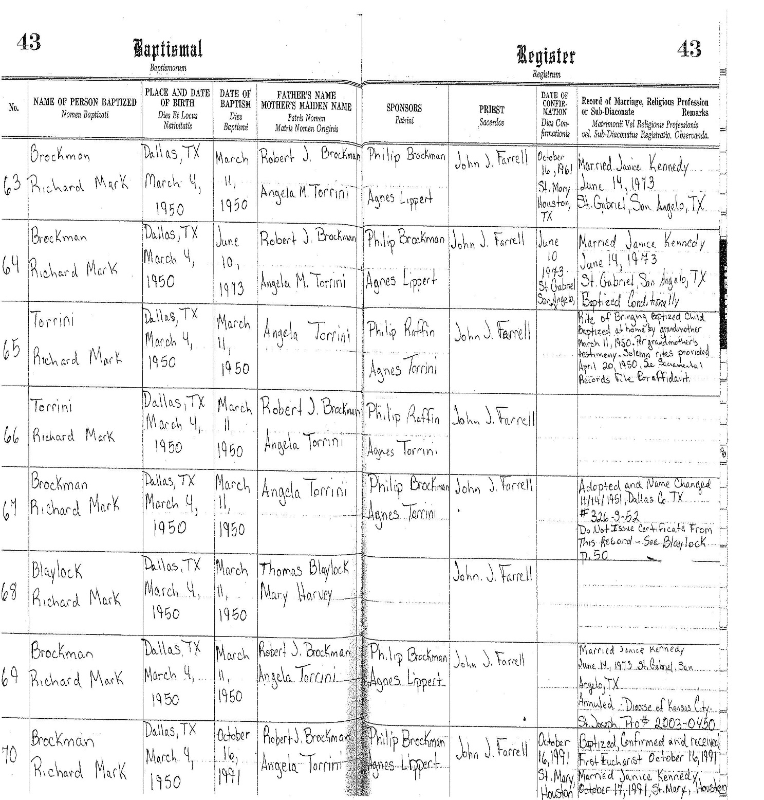

Baptismal Registry (cont’d.)
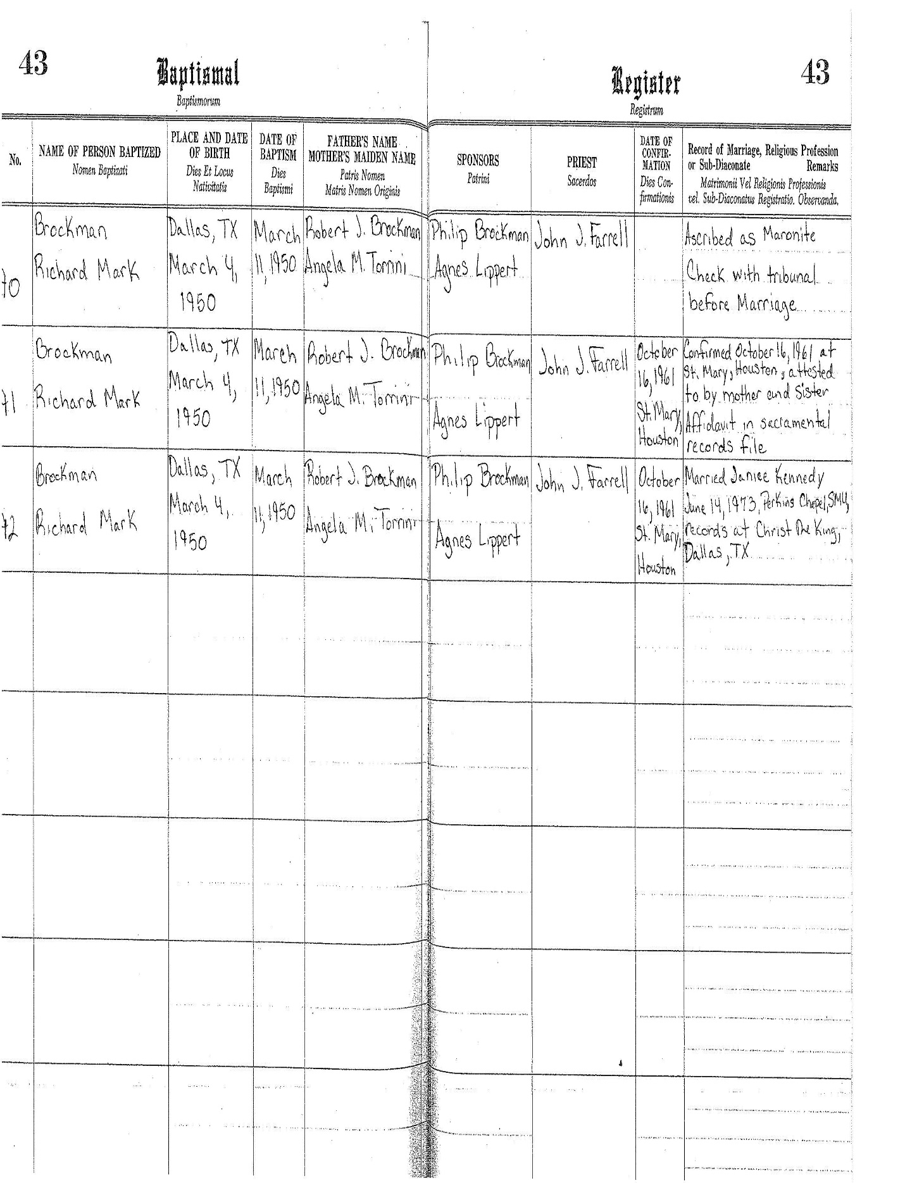
First Communion Registry

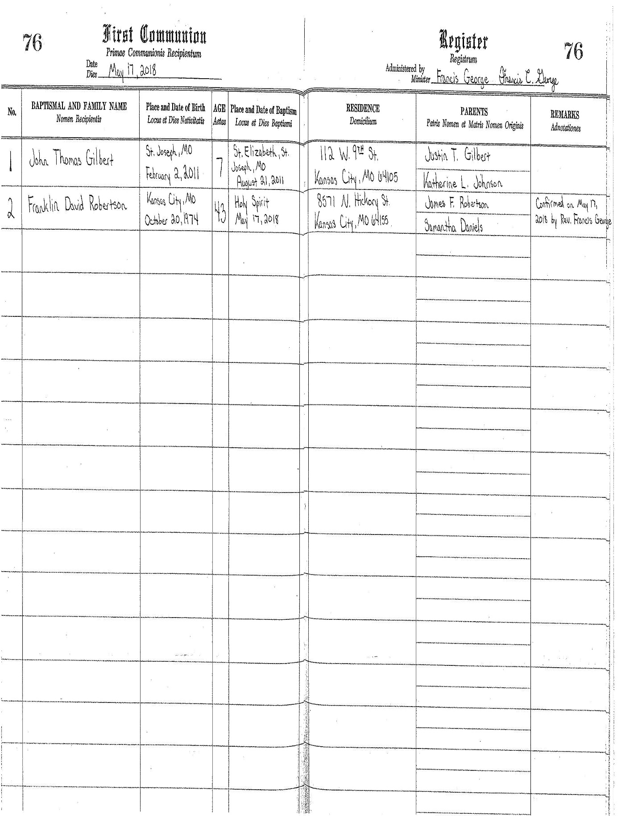
Confirmation Registry

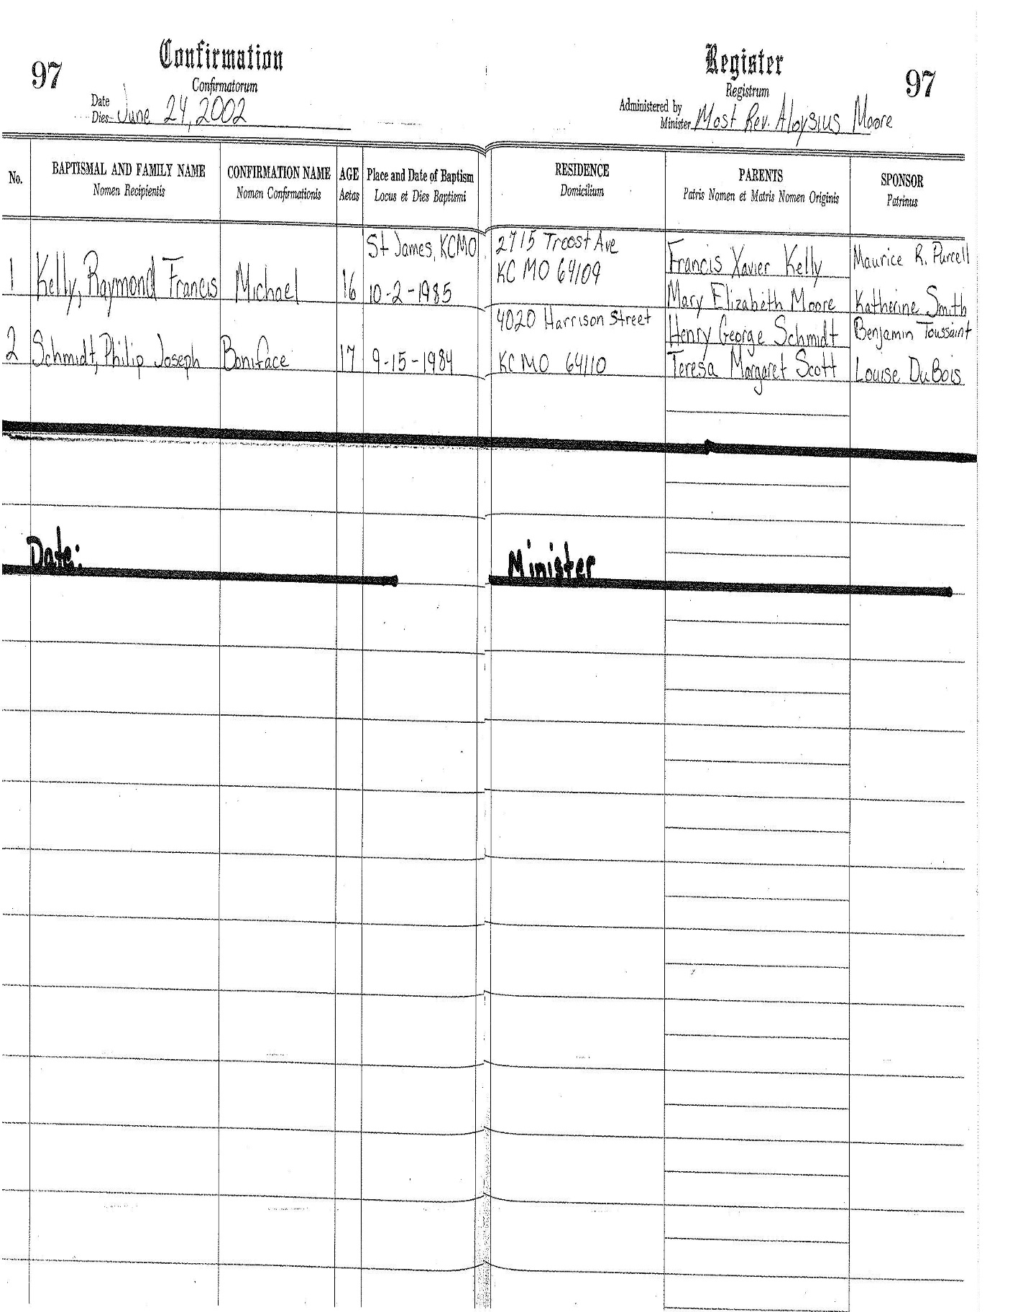
Marriage Registry

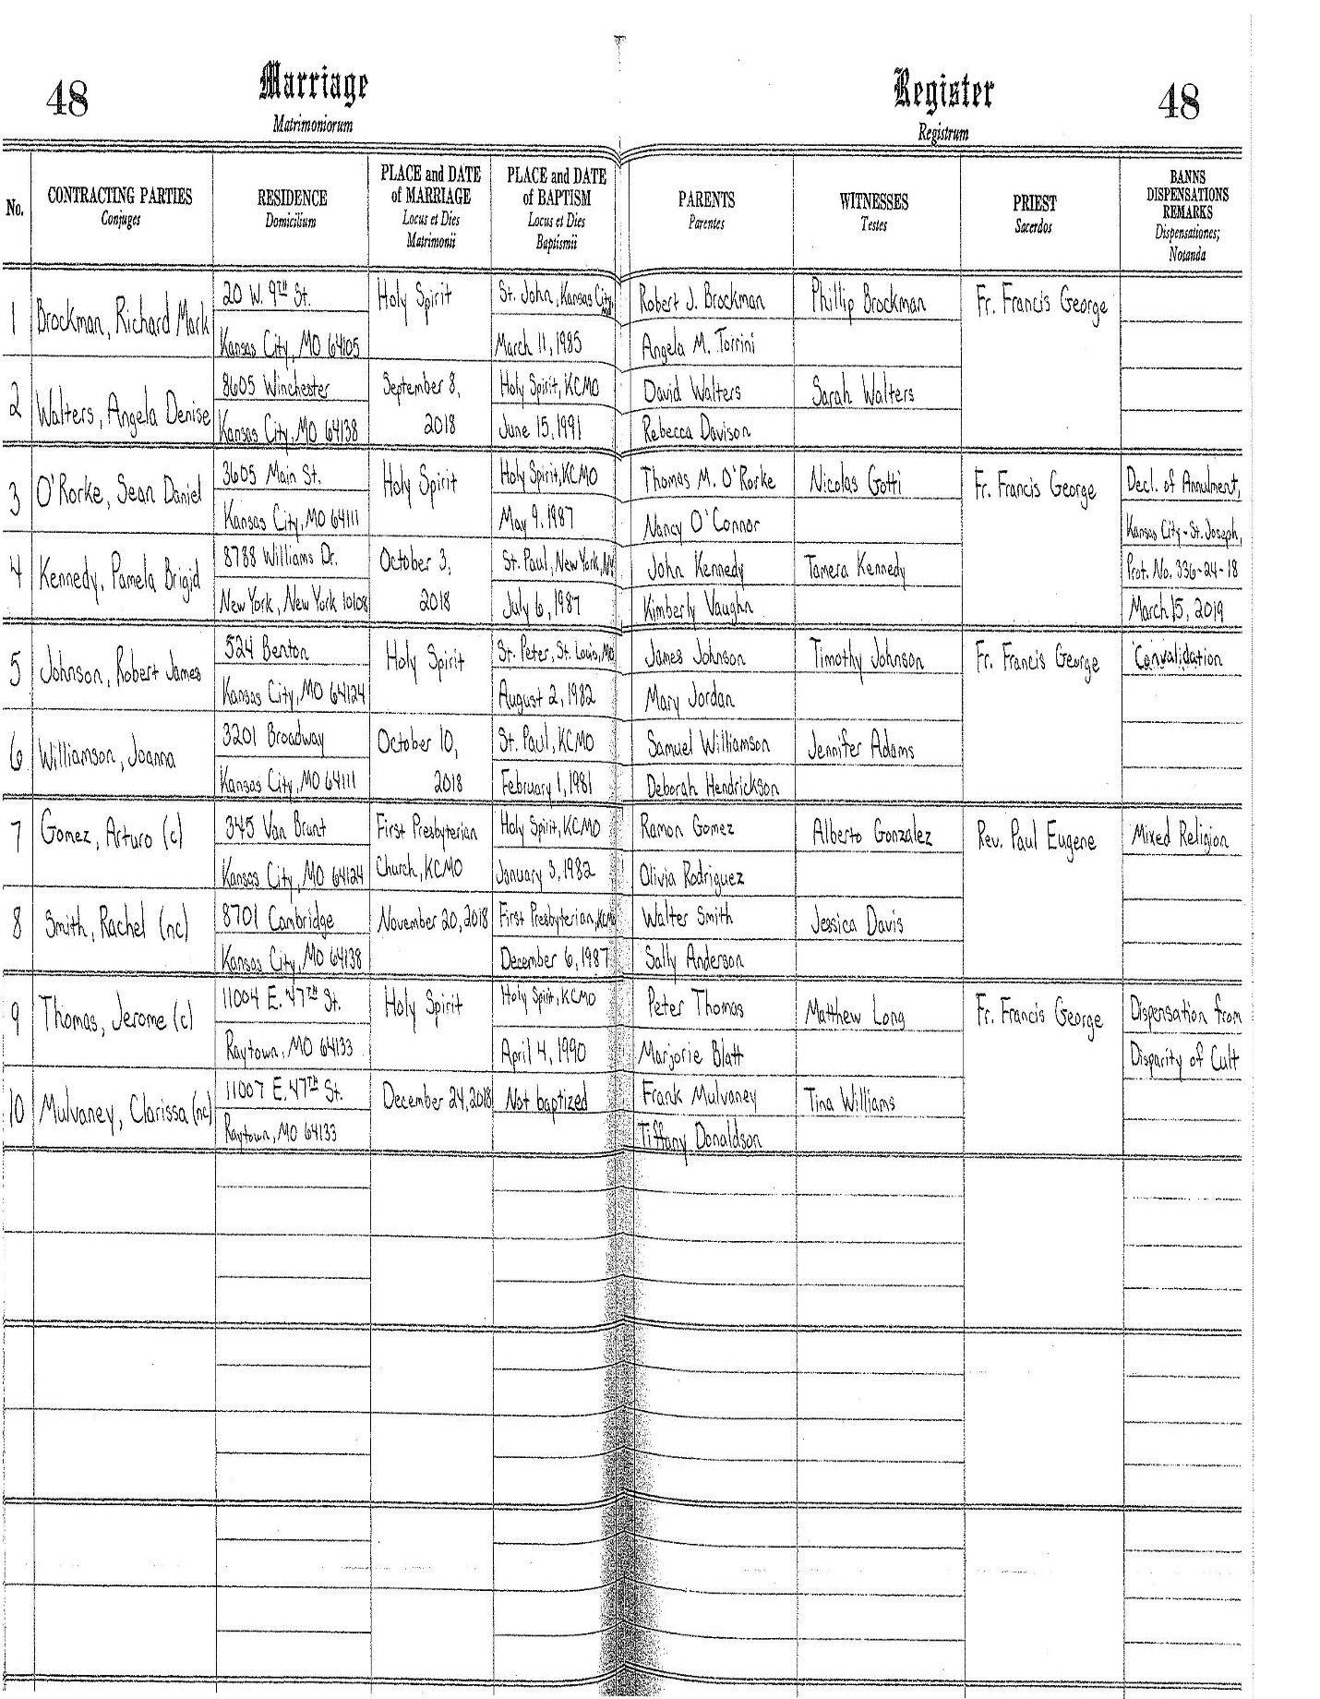
Death Registry

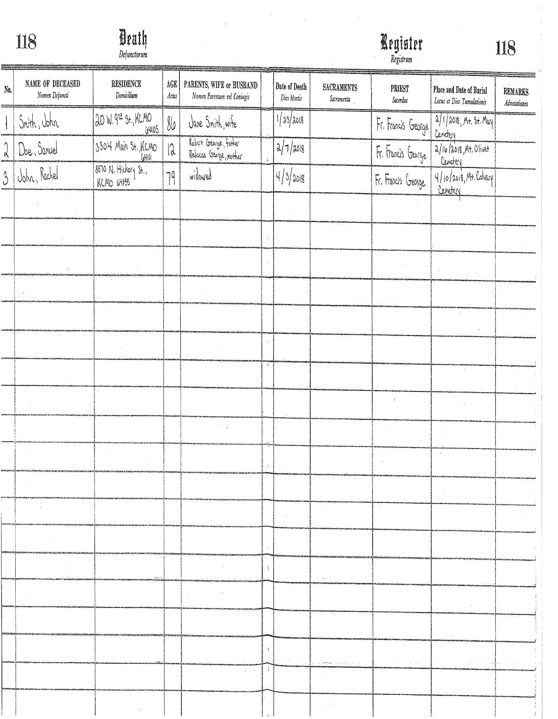

Appendix II

Resources and Websites

Diocese of Kansas City-St. Joseph Office of Diocesan Archives
The Diocesan Archives is located on the 5th floor of the Chancery.

For more information regarding the recording, maintenance, and preservation of sacramental records, please contact Dr. Zachary S. Daughtrey, Archivist of the Diocese of Kansas City-St. Joseph, at 816-714-2365 or email daughtrey@diocesekcsj.org.

Please visit the Archives’ website regarding Records Management at http://www.diocese-kcsj.org/content/diocese/archives/ and for SACRAMENTAL RECORDS POLICY at http://www.diocese-kcsj.org/_docs/SacramentalRecords-final.pdf. The LOCATION OF RECORDS POLICY can be found at http://www.diocese-kcsj.org/_docs/LocatingRecords.pdf.

Marriage Tribunal of the Diocese of Kansas City-St. Joseph
tribunal@diocesekcsj.org
http://www.diocese-kcsj.org/content/offices_and_agencies/marriage_tribunal/

Office of the Vicar General-Chancellor
Rev. Kenneth A. Riley, JCL
riley@diocesekcsj.org
816-714-2340

Catholic Cemeteries of Kansas City-St. Joseph
Steve Pierce and Charlie Passantino, Managing Partners
spierce@muehlebachchapel.com or charlie@passantinobros.com
816-353-1900
www.cemeterieskcsj.org

