BULLETIN ANNOUNCEMENT

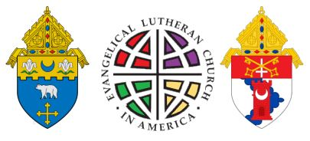
Lutheran-Catholic Commemoration of the Reformation
Today Lutherans and Catholics have come to acknowledge that more unites than divides us. With a spirit of both joy and reconciliation, Archbishop Naumann (Archdiocese of Kansas City, Kansas) and Bishop Johnston (Diocese of Kansas City-St. Joseph), together with Lutheran Bishop Roger Gustafson (ELCA Central States Synod), invite you to a Lutheran-Catholic Commemoration of the 500th anniversary of the Reformation. Join our local bishops, along with Catholics and Lutherans throughout the metropolitan area for this historic event on September 29, from 7:00 – 9:00 pm at the Cathedral of the Immaculate Conception.

