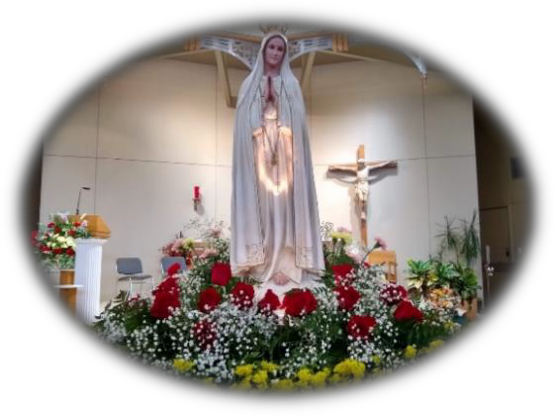

**International Rosary, Marian & St. Joseph Procession**

In the Year of St. Joseph

**Date**: Saturday, October 9

**Time**: 10:00am-12:00noon

**Location**: St. Patrick’s Parish 1357 NE 42nd Terrace, Kansas City, MO 64116

*All events are outdoors-in case of rain, the rosary will be prayed in the

in the church, with adoration of the Blessed Sacrament.

**Schedule**

**10:00am** Welcome and International Rosary

**10:30am** Marian & St. Joseph Procession to Divine Mercy Park, Chaplet of Divine Mercy

**11:45am** Balloon Rosary, send off

**12:00pm** Departure

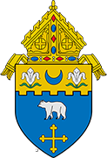

**DIOCESE OF KANSAS CITY-ST. JOSEPH**

One Family: RESTORED IN CHRIST-EQUIPPED FOR MISSION

**kcsjcatholic.org**

<https://kcsjcatholic.org/office/divine-worship/>