Dear Pastors,

Bishop James Johnston wishes to extend his thanks to outstanding volunteers from your parish who have built up the Church through their hard work and dedication.

Every other year he offers the Bishop’s Recognition Award to one or two people from each parish.

Bishop Johnston will confer the awards on this year’s honorees on Sunday, September 13, at the regularly scheduled 11:00 am Mass at the Cathedral of the Immaculate Conception. Each will receive a certificate and a pin.

Please use the upcoming months to discern who your honorees will be. Then submit their names and home address to the Office of Divine Worship at [sage@diocesekcsj.org](mailto:sage@diocesekcsj.org) on or before Friday, August 14, 2020.

Bishop Johnston will send a letter congratulating the honorees from your parish and inviting them to celebrate with Mass at the cathedral.

Thank you for promoting faithful ministry throughout our diocese.

In Christ,

Fr. Paul Turner

Director, Office of Divine Worship

[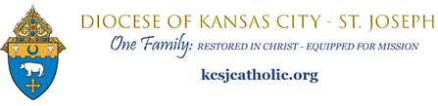](https://kcsjcatholic.org/)